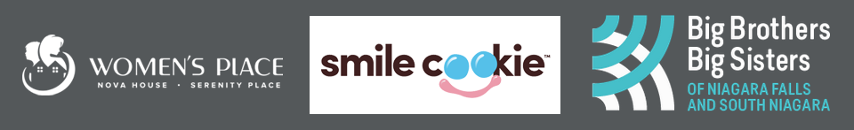

Women’s Place of South Niagara Inc.

8903 McLeod Rd

Niagara Falls, ON L2H 3S6

[womensplacesn.org](https://www.womensplacesn.org)

Big Brothers Big Sisters of Niagara Falls and South Niagara

800 Niagara Street Unit JJ4 (Seaway Mall)  
Welland, ON, L3C 5Z4

[niagarafallssouthniagara.bigbrothersbigsisters.ca](https://niagarafallssouthniagara.bigbrothersbigsisters.ca/)  
 For Immediate Release

**TIM HORTONS IN NIAGARA FALLS TO SUPPORT WOMEN’S PLACE AND BIG BROTHERS BIG SISTERS THIS SEPTEMBER**

NIAGARA FALLS, ON, September 8, 2021 – This year, Tim Hortons restaurants across Canada will be hosting **Smile Cookie week** from **September 13-19**. This annual fundraiser, which is celebrating its 25th anniversary, features the iconic chocolate chunk cookies topped with pink and blue icing and raises millions of dollars for charitable organizations from coast-to-coast-to-coast. For 2021, **Tim Hortons’ Niagara Falls locations will be sharing the proceeds of their campaign with Women’s Place and Big Brothers Big Sister of Niagara Falls.**

Smile Cookie first began in 1996 in Hamilton, Ontario as a way to raise funds for the Hamilton Children’s Hospital. Since that time, the campaign has raised more than $60 million for charities, hospitals and community programs across the country, raising a record-breaking $11 million in 2020.

**Cookies will be sold for $1 each plus tax. 100% of the proceeds will be donated to local charities.** Members of our community can get their cookies by walking into their local Tim Hortons restaurant or pulling up to the drive-through window. Uber Eats and Skip the Dishes will also add them to their Tim Hortons menus for some locations during the campaign. A complete list of the locations that will be supporting these two agencies can be found on the [Women’s Place](https://womensplacesn.org/event/smilecookie2021/) or [Big Brothers Big Sisters](https://niagarafallssouthniagara.bigbrothersbigsisters.ca/) websites. This year, individuals and organizations can also bulk order cookies in advance by dropping off a pre-order form at their local restaurant. Forms can be found on the [Women’s Place](https://womensplacesn.org/wp-content/uploads/2021/08/Smile-Cookie-Pre-Order-Delivery-Form-2021.pdf) or [Big Brothers Big Sisters](https://niagarafallssouthniagara.bigbrothersbigsisters.ca/) websites.

*To learn more about Women’s Place and how this campaign will help to support women and children in Niagara, please contact Amanda Braet, Director of Development and Stewardship at 905-356-3933 ext. 240 or* [*amanda@wpsn.ca*](mailto:amanda@wpsn.ca)

*For more information about Big Brothers Big Sisters and how Smile Cookie week will have a positive impact on the programs they provide, contact Pam Swick-Janjac, Fundraising and Events at (905) 735-0570 Ext. 230 or [Pam.swickjanjac@bigbrothersbigsisters.ca](mailto:Pam.swickjanjac@bigbrothersbigsisters.ca)*

#####