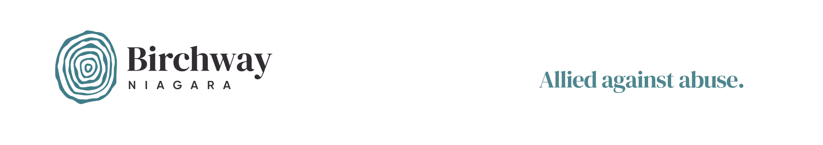

CONTACT INFORMATION

**Birchway Niagara  
Jennifer Gauthier, Executive Director  
905-356-3933 ext. 223**

FOR IMMEDIATE RELEASE

**The 16 Days of Activism against Gender-Based Violence to Begin on November 25**

**NIAGARA FALLS, ONTARIO, November 21, 2024–** The 16 Days of Activism against Gender-based Violence is a global campaign that draws attention to the alarming escalation of violence against women. Across the world, one in three women experience violence in their lifetime and every ten minutes a woman is killed by a partner or family member**.** In 2023 alone, the lives of at least 51,100 women across the world ended in femicide.*

“Intimate partner violence is a crisis in every part of the world, including here in Ontario, explains Birchway Niagara’s executive director, Jennifer Gauthier. “As of the end of October, [59 women had been killed in this province since November 25, 2023](https://www.oaith.ca/oaith-work/we-count-femicide-because/monthly-femicide-snapshots.html). This is four more lives than had been lost during the same period last year, and reflects the increasing rate of family violence being reported across Canada by [Statistics Canada](https://www150.statcan.gc.ca/n1/daily-quotidien/241024/t001b-eng.htm).”

During the 16 Days of Activism, individuals, governments and organizations are asked to unite to improve gender equality, to invest in prevention and to renew their commitment to stopping the violence.

Here in Niagara, members or our community are invited to mark the 16 Days of Activism by participating in vigils hosted by women’s organizations, flag raisings hosted by our local municipalities, and other activities to show their support for taking action. A list of some of these events can be found on Birchway Niagara’s website at: <https://birchway.ca/event/woman-abuse-prevention-month-16-days-of-activism/>

cont’d…

For media inquiries or additional information, please contact:

Jennifer Gauthier  
Birchway Niagara  
[jenniferg@birchway.ca](mailto:jenniferg@birchway.ca)  
905-356-3933 ext. 240

*Source: <https://www.unwomen.org/en/what-we-do/ending-violence-against-women/unite/theme>

*###*

*Birchway Niagara provides compassionate services to individuals impacted by violence. Formerly known as Women’s Place, the agency evolved in 2022 by consolidating emergency shelter services at its Niagara Falls location on McLeod Rd. It continues to offer outreach services at offices across South Niagara. In March 2023, a new name and logo were announced to reflect the growing understanding that abuse is an issue that negatively impacts everyone. It is also a problem that everyone must solve. A new, inclusive name and logo will allow Birchway Niagara to engage more members of our community to end the violence.*