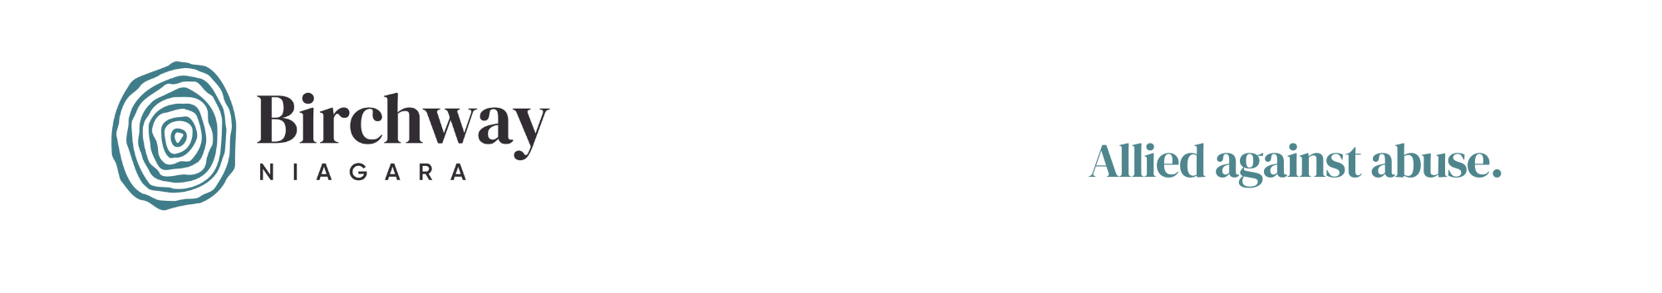

CONTACT INFORMATION

**Birchway Niagara  
Amanda Braet, Director of Development and Stewardship  
905-356-3933 ext. 240**

FOR IMMEDIATE RELEASE

**Birchway Niagara Invites Allies to Register for Brunch, Bid and Bowl**

**NIAGARA FALLS, ONTARIO, January 7, 2025–**Birchway Niagara is excited to announce that registration is now open for their popular “Brunch, Bid & Bowl” event, which will return on International Women’s Day in 2025. This annual event, which includes a delicious brunch, exciting live and silent auctions at Club Italia followed by 1.5 hours of bowling at Cataract Bowl, will celebrate its 20th year when the doors open on March 8, 2025.

The 2025 event is sponsored by Great Wolf Lodge, an organization that has a long history of supporting domestic violence services in Niagara, including as a live auction sponsor at the 2024 event.

“Great Wolf Lodge, Niagara Falls is honoured to support Birchway Niagara and the incredible work they do to empower survivors and end the cycle of violence in our community,” explains Great Wolf Lodge’s Senior Director of Human Resources and Administration, Anne Marie Malleau. “Events like ‘Brunch, Bid & Bowl’ not only bring people together for a day of fun but also make a profound and lasting impact on the lives of those in need. We’re proud to stand alongside Birchway Niagara in creating a stronger, safer Niagara for everyone.”

As Birchway Niagara’s 2024 Birchway Book Riot in June demonstrated, fundraising events like this one can have a significant impact on the ability of the agency to end the cycle of violence in our communities. At that event, participants raised enough money to allow the Birchway Niagara to temporarily open five extra bed spaces to provide additional support to women and children fleeing abuse.

Staff of Birchway Niagara and members of the Brunch, Bid & Bowl event committee are challenging members of our community to create their own impact by forming a team of 6-8 bowlers and to help raise over $90,000 by collecting pledges and participating in this year’s auctions and activities.

-Cont’d-

[Layne, The Auctionista,](https://auctionista.ca/) the event’s dynamic emcee, will also return for their eighth year, connecting participants to the mission of Birchway Niagara and ensuring an exciting and memorable day.

**WHEN/WHERE:**   
Saturday, March 8, 2025   
9:00 a.m. – Doors open at Club Italia (2525 Montrose Rd, Niagara Falls)  
1:00 p.m. - Bowling starts at Cataract Bowl (7906 Lundy’s Lane, Niagara Falls)

**WHO:**   
This event is suitable for adults, youth and children. It is a great opportunity for friends, family members and colleagues to come together for a wonderful cause and a great time!

**COST:**   
There is no registration fee for teams of 6-8 players who reach the minimum fundraising goal of $1000. Bowlers may also register individually if they would like Birchway Niagara to find them some teammates by joining one of our “Bowling Buddies” teams. Guests who do not wish to join a bowling team can also purchase tickets to take part in the brunch, auctions and “heads or tails” portions of the event.

**HOW:**  
To register or learn more about this event, visit [**http://www.brunchbidandbowl.org**](http://www.brunchbidandbowl.org).

To learn more about Birchway Niagara and for additional resources about this event, you can also visit the Birchway Niagara media relations page at: [https://birchway.ca/about/media-relations/.](https://birchway.ca/about/media-relations/)

For media inquiries or additional information, please contact:

Amanda Braet  
Birchway Niagara  
[AmandaB@birchway.ca](mailto:AmandaB@birchway.ca)  
905-356-3933 ext. 240

*###*

*Birchway Niagara provides compassionate services to individuals impacted by violence. Formerly known as Women’s Place, the agency evolved in 2022 by consolidating emergency shelter services at its Niagara Falls location on McLeod Rd. It continues to offer outreach services at offices across South Niagara. In March 2023, a new name and logo were announced to reflect the growing understanding that abuse is an issue that negatively impacts everyone. It is also a problem that everyone must solve. A new, inclusive name and logo will allow Birchway Niagara to engage more members of our community to end the violence.*