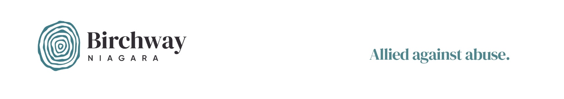Volunteer Commitment

While performing their duties, volunteers have a responsibility to conduct themselves in a manner which reflects positively on Birchway Niagara. They also have a right to expect a safe and positive working environment. If you have concerns about any of the responsibilities or rights outlined in this document, please discuss these issues with your supervising staff member or the staff member responsible for volunteer coordination prior to your first shift.
- I confirm that I am 18 years of age or older or, being under 18, have the approval of a parent or guardian to volunteer with Birchway Niagara
- I understand that if I regularly volunteer with Birchway Niagara, I have a responsibility to understand the mission, values, and services of this agency. To this end, I will make myself familiar with information about Birchway Niagara by attending a volunteer orientation session when one becomes available that fits my schedule, and/ or through other means (e.g., reading the Birchway Niagara website).
- I understand that I have a responsibility to treat staff members, volunteers, clients, and event guests with dignity, care and respect. I will not practice discrimination or harassment.
- I understand that I am responsible for setting limits for myself. If I am being asked to do something I feel is unsafe or inappropriate for my skill level or physical abilities, or I am having difficulty with a staff member, volunteer, client or guest, I have both the right and responsibility to ask for support from my supervisor, or for a change in my duties.
- I understand that it is my responsibility to declare any real or perceived conflict of interest. A conflict arises when a volunteer, a member of his/her family or a business partner benefits, directly or indirectly, financially or otherwise, from the volunteer’s role with Birchway Niagara.
- I agree to minimize my use of technology when volunteering. Excessive texting, calling, social media usage and the use of other forms of technology by volunteers are discouraged as these activities can impact safety and professionalism.
- I understand that being under the influence of alcohol or drugs would interfere with my ability to safely volunteer. I therefore agree not to perform my volunteer duties while under the influence of drugs or alcohol.
- As many people suffer from environmental allergies and are extremely sensitive to strong scents, I agree to moderate my use of perfumes and colognes when volunteering.
- I understand that I am expected to be punctual for assigned shifts and to provide as much notice as possible if I am not able to fulfill a commitment.
Continued…

- I understand that I have a right to a safe working environment, and one that is free from discrimination and harassment.
- I understand that I have a right to meaningful work that is well suited to my skill-level, interests, and reasons for volunteering.

Confidentiality Agreement

I understand that as a volunteer of Birchway Niagara, I am required to safeguard client information. This confidentiality is a basic right of all clients, and an ethical obligation of Birchway Niagara. I shall not release any information regarding a client, his/her family, friend etc. (including his/her identity) to any individual who is not currently employed by Birchway Niagara.

I understand that it is expected that employees and volunteers will limit their discussions of clients, and that these conversations shall not occur in public places. As much as possible, necessary discussions should involve first names only.

I understand that this agreement shall not bind a volunteer who believes that failure to disclose information is likely to result in harm to others. Such cases should involve clear and imminent danger to an individual or society. Wherever possible, the volunteer shall inform his/her supervisor prior to disclosure.

I understand that notwithstanding this agreement, all volunteers of Birchway Niagara shall be bound by their legal obligations under the Child and Family Services Act. This Act requires our agency to report all suspected cases of child abuse. If, in my role as a Birchway Niagara volunteer, I witness or have reason to suspect child abuse, I shall report this information to a staff member, who will take the necessary steps to ensure that
FACS Niagara is informed of the situation.

Volunteer-Client Relations

I understand that I may not act in the role of advisor or counsellor for any issues occurring outside of the duties of my volunteer position description.
I understand that I will handle access to privileged information and “power of position” in a professional manner, so the expected quality of service is maintained by the organization.

I understand that I will not give gifts/donations of any kind directly to clients. All gifts/donations
must be given to the Fundraising and Events Manager who will decide how items are to be allocated.
Continued…
- I understand that as a volunteer of Birchway Niagara, I am expected to always act professionally.
- I understand that I am encouraged to be friendly and helpful to clients I meet.

- I agree to keep all client information confidential.

4.0 I understand that Birchway Niagara prohibits volunteers from engaging with clients, or past clients outside of my volunteer role in the community, or in-shelter, unless otherwise approved by the Volunteer Manager.

Volunteer Waiver
I agree to act as a volunteer for Birchway Niagara. I acknowledge and agree that activities performed in this role will be performed strictly on a voluntary basis, without pay, compensation or benefits. I agree to comply with the rules and policies established by BIRCHWAY NIAGARA and that failure to do so may result in my removal as a volunteer. I am aware of the nature of the activities to be performed as a volunteer, and I recognize and understand that there are certain risks inherent in any role. I agree that all volunteer activities are performed at my own risk. I understand that if any accident/injury occurs, no matter how minor, I will complete an Incident/Accident Report form and seek necessary medical attention. I agree to indemnify and hold harmless BIRCHWAY NIAGARA, its officers, directors, employees, agents, and volunteers from and against any loss, damage, claims, liability, costs and expenses of any nature arising from or occasioned by my activities as a volunteer for BIRCHWAY NIAGARA. I agree that BIRCHWAY NIAGARA may use my image for BIRCHWAY NIAGARA displays, educational programs and/or other public relations, and I hereby release any such images/photographs for use in its programs, publications and purposes.

I have read the above Volunteer Commitment, Confidentiality Agreement and Volunteer Waiver and state that I understand the information contained herein, and that I am voluntarily sign this document without any inducement or representation from any member of the BIRCHWAY NIAGARA staff.

Volunteer Signature |  | Volunteer Name (Print) |  | Date
Guardian Signature  (if volunteer is under 18) |  | Guardian Name (Print) |  | Date

